1. What are the optimal amounts of cargo types transported in each hold of the Noyina and the optimal value for total profit for Southern Light Logistics (SLL)?

This can be found in the “Answer Report 1” Sheet.

The optimum amount of cargo types transported in each hold of the Noyina is found by the model given a day delay at 10% penalty for each day is:

|  |  |
| --- | --- |
| **Cargo Types Transported in Hold** | **Cargo Transported (Tons)** |
| General Cargo (C1) Forward Hold (FH) | 1744.234234 |
| General Cargo (C1) Center (Port) Hold (CPH) | 0 |
| General Cargo (C1) Center (Starboard) Hold (CSH) | 1223.333333 |
| General Cargo (C1) Rear Hold (RH) | 1832.432432 |
| Dangerous Goods (C2) Forward Hold (FH) | 0 |
| Dangerous Goods (C2) Center (Port) Hold (CPH) | 2500 |
| Dangerous Goods (C2) Center (Starboard) Hold (CSH) | 0 |
| Dangerous Goods (C2) Rear Hold (RH) | 0 |
| Scientific Support (C3) Forward Hold (FH) | 0 |
| Scientific Support (C3) Center (Port) Hold (CPH) | 0 |
| Scientific Support (C3) Center (Starboard) Hold (CSH) | 0 |
| Scientific Support (C3) Rear Hold (RH) | 1200 |
| Personal Effects (C4) Forward Hold (FH) | 833.3333333 |
| Personal Effects (C4) Center (Port) Hold (CPH) | 192.3076923 |
| Personal Effects (C4) Center (Starboard) Hold (CSH) | 674.3589744 |
| Personal Effects (C4) Rear Hold (RH) | 0 |

This has a projected profit of $648000.

1. Are there alternate optimal solutions to the freight loading plan? Explain your answer.

There exist alternate optimal solutions to the freight loading plan.

We note that the solution is not degenerate (see response to question 3)

We observe in the “Sensitivity Report 1” sheet, that there exist nonzero values in allowable increase or decrease for some objective function coefficient, which indicates an alternate configuration is possible to obtain the same maximised projected profit.

1. Is the solution degenerate? Explain your answer.

A solution is degenerate if the allowable increase or decrease on any constraint is 0.

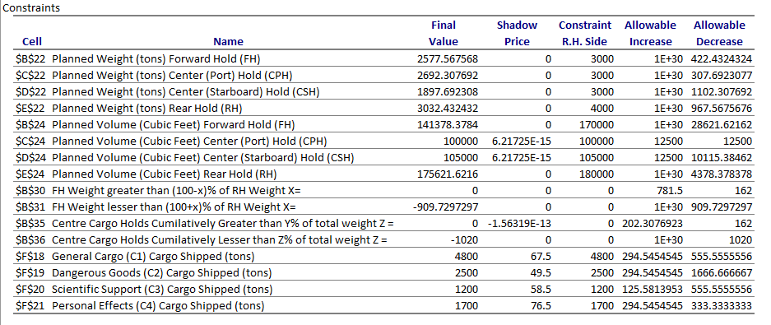

We note that there is no constraint, where the allowable increase or decrease is 0. This means that the method for determining if there exist an alternative solution used in question 2 is valid.

1. Can Southern Light Logistics (SLL) transport all of the cargo amounts as required by the AAD?

Southern Light Logistics (SLL) can transport all of the cargo amounts as required by the AAD?

This can be found in the “AAD Supply Operations” worksheet, where the Cargo Shipped (tons) for each cargo type is equal to the Cargo available (tons).

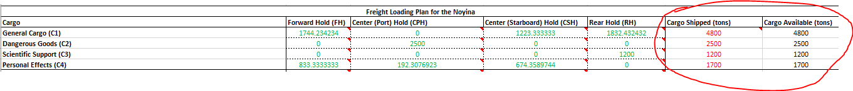

1. What are the marginal values of each loaded cargo type?

The marginal values (shadow price) can be found in the “Sensitivity Report 1”.

|  |  |
| --- | --- |
| **Cargo Type** | **Shadow Price** |
| General Cargo (C1) Cargo Shipped (tons) | 67.5 |
| Dangerous Goods (C2) Cargo Shipped (tons) | 49.5 |
| Scientific Support (C3) Cargo Shipped (tons) | 58.5 |
| Personal Effects (C4) Cargo Shipped (tons) | 76.5 |

1. If the profit per ton of “Scientific Support” cargo goes up by $5 would the optimal solution

change? Explain your answer.

As we can ship all available cargo in the original solution, and the change only increases the profitability of Scientific Support (C3), our current configuration is able to accommodate it, and we would receive an increase in profitability as a result of increased profitability in C3 (from projected profit of $648000 to $653400, as a result of the increased profitability of $4.5 for each of the 1200 Scientific cargo shipped assuming single day of delay sat 10% penalty).

However, as we note in our response to question 2, there exists multiple alternate solutions, that are also able to fit the same total cargo as our current configuration, so it’s likely that rerunning the model with the new profit for C3 would result in a different loading configuration.

1. If the ship is delayed by two days due to the current maintenance issue requiring additional time, comment on any changes to the optimal solution.

If the ship is delayed for 2 days, changing the days delayed cell ('AAD Supply Operations'!C5) from 1 to 2 and rerunning the model would provide a model with the additional delay.

Alternatively, we can simply note that similar to our response in question 6, we were able to ship all cargo, and the new profits for each cargo type is still positive (80% profit with 2 days of delay), which means we still want to ship all the cargo. Therefore, our new solution could simply be the original model configuration, with the projected profit recalculated to reflect the new profits for each cargo type.

1. An urgent request to AAD from Mawson Station with regard to an ongoing scientific

experiment has added a further 100 tons of “Scientific Support” cargo. Comment on

possibilities for this to be accommodated by SLL and the impact over total profit.

We note that in the “Sensitivity Report 1”, the allowable increase is 125.5813953 for Scientific Support (C3) Cargo Shipped .

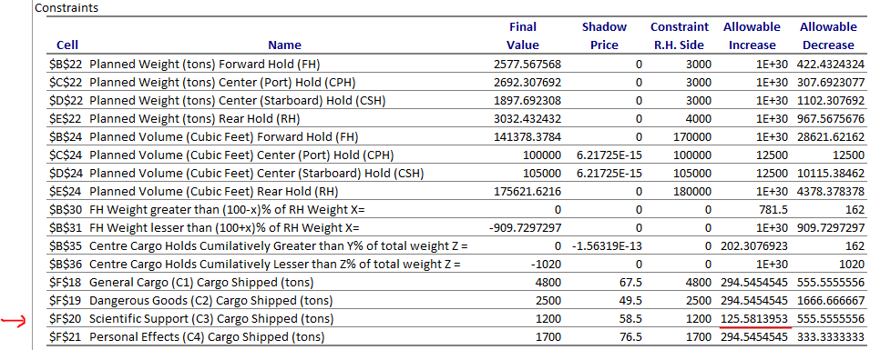

This suggests that it is indeed possible to accommodate an increase of 100 tons of Scientific Support. The exact configuration (where the cargo needs to be loaded) is not provided, but without resolving the model, we are able to conclude that we can accommodate the extra request, with additional profit of 100 multiplied by the projected profit of Scientific Support (currently $58.5 each), giving us $5850 extra profits. To obtain the configuration, we will have to resolve it, by increasing the cargo available for C3 by 100.

1. If certain reconfigurations can be made on board using hired labour to increase the weight

capacity of the two center holds by 100 tons each, should SLL go ahead with that process?

There is no reason to increase the weight capacity of the centre holds by 100 tons each with hired labor. This is because as noted in previous responses, we are already able to ship all available cargo in the original configuration. This means the proposal will lose money, as we need to hire labour to increase the cargo capacity, but we cannot make back the money by shipping more cargo.

We also note that the Planned Weight for Centre Port and Starboard are non binding, which means that increasing the weight capacity of the centre holds by 100 tons each will not change the configuration at all. There is a shadow price attached to the centre holds, but that is because the centre holds are restricted by volume capacity, which is not addressed with this proposed work.

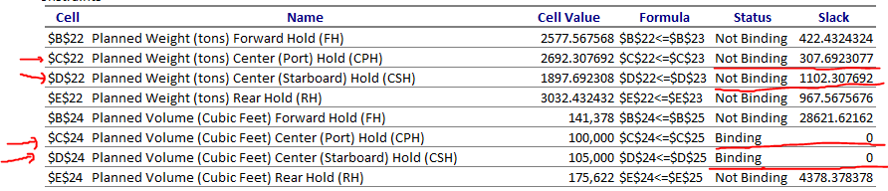

1. The maintenance engineers have advised SLL that 250 tons of extra equipment need to be

carried onboard the Noyina on this voyage with regard to the ship’s ongoing maintenance issue. It is decided that the Center Port hold would be the most convenient place to store the equipment. Comment on any effects this has to the solution (Amounts freighted for the AAD). and the total achievable profit.

Assuming that the extra equipment does not correspond to any of the cargo types, and no volume per ton nor profit is provided, we assume that the volume per ton of the 250 tons of extra equipment is 0, and profit per ton is also 0. Since we have enough weight capacity in centre port hold (see response to question 9), and our balance of constraint for centre cargo holding cumulatively between 45%-55% allows for up to 202.3076923 ton increase, we can indeed accommodate it, without changing existing configurations, without change to our solution or total achievable profit. If there is a profit associated with the extra equipment, simply add it on to the projected profit to obtain the new projected profit

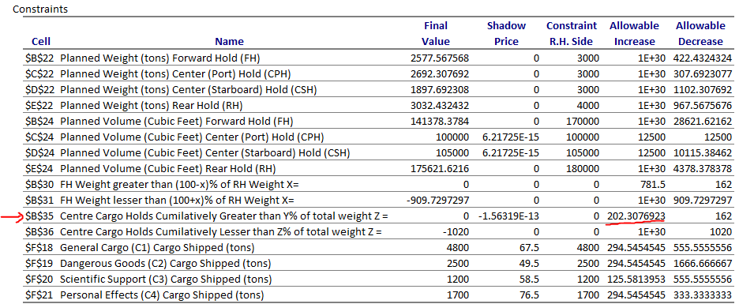

However, if there is an associated volume to the extra equipment, we will need to resolve it by resolving the model, as our current solution has 0 slack in the planned volume for Centre Port Hold (as noted in question 9). This can be done with the following changes.

1. Add an extra row for the cargo where we have cargo types “Extra Equpment (C5)” in the profit for Different Cargo Types, Volume for Different Cargo Types, and Freight Loading Plan for the Noyina.
2. Fill in appropriate values for profit per ton, volume per ton for the new cargo Extra Equipment (C5).
3. Have the loading in Forward Hold, Centre Starboard Hold and Read hold be 0, and the Centre Port hold value be fixed to 250 for the Extra Equpment (C5). These are not decision variables for solver to tweak, as we are dictated the amount and where the extra equipment should be loaded
4. Rectify the formulas where needed (eg. For calculation of planned weight per hold area, calculation of planned volume per hold area, projected profit, profit without penalty)
5. A new crane is added to the forward deck of the Noyina altering balance considerations. The new requirement is that the Forward cargo hold weight be within 10% of the rear cargo hold weight. Discuss on any impacts to the solution.

We note that our current configuration has the forward cargo hold is outside of the new constraint. This means that our current configuration is invalid with the new constraints.

We are unable to use sensitivity reports to determine if this is feasible, as the allowable increase and decrease only assume for a single variable changing. In this case, we are redistributing the load, which would mean that there will be changes in at least 2 decision variables (amount of specific cargo allocated to a specific hold) that will be changed.

While it is possible to manually redistribute it by moving C1 from Rear cargo hold to Forward cargo hold until it meets the new constraints, this is not something that we can do based on observing the sensitivity report, but rather through noticing that there exist enough slack in Forward Cargo Hold for both volume and weight to accommodate redistributed cargo of C1 from rear hull (since forward cargo hold is currently underweight).

To obtain the actual configuration (what cargo type quantity are in which cargo hold), we can simply resolve it, by changing the value in 'AAD Supply Operations'!C29 from 0.15 to 0.1, and resolve it to obtain the configuration. We can note that all cargo remains shippable, with no change to projected profits.